INSTRUCTIONS FOR COMPLETING THE DAILY TANK INVENTORY RECORD SHEET

Daily Inventory should be performed at approximately the same time every day. For example, before closing or before opening. Dipstick and meter readings must be taken together while the pumps are not operating.

Water level should never exceed one (1) inch. Excessive water should be investigated.

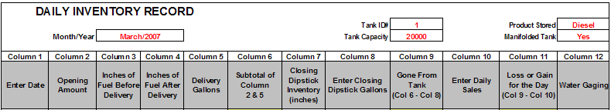

Examples of entries are entered in red.

To complete the top of the daily inventory record:

Enter: Month/Year
Tank ID#
Tank Capacity
Product Stored
Manifolded Tank = Yes or No

To complete the inventory sheet:

*IMPORTANT: On manifolded tanks, when calculating gallons, the gallons from each tank must be added together. When figuring inches on manifolded tanks, the inches must be entered individually. See example below. Information that is being gathered has been entered in red.

Note: in column 3 the inches from first manifolded tank is 25 inches and the second tank is 35 inches.

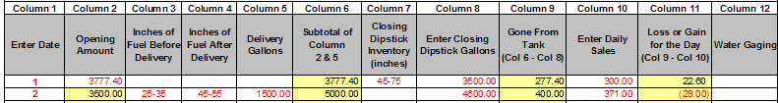

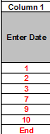
Column Entries:

- Enter “Day of Month” in column 1 – do not leave any blank lines. When the month is complete, type the word in “END” on the next line.

- Enter the “Opening Dipstick Inventory” in column 2, in gallons, for the beginning of the month. It will be auto calculated after the first entry. This number is the previous day’s closing dipstick inventory in Column 8. When figuring gallons, if the tanks are manifolded, the inventories of all manifolded tanks must be added together

- Enter the “Inches of Fuel Before Delivery” in column 3 (inches are made to the nearest 1/8 of an inch). If the tanks are manifolded, the inches must be recorded separately.

- Enter the “Inches of Fuel After Delivery” in column 4 (inches are made to the nearest 1/8 of an inch). If the tanks are manifolded, the inches must be recorded separately.

- Enter “Delivery Gallons” in column 5 (enter in gallons).

- Automatically calculated. No entry necessary.

- Enter the “Closing Dipstick Inventory” in column 7, in inches (to the nearest 1/8 of an inch). If the tanks are manifolded, when figuring inches, the inches must be recorded separately.

- Enter the “Closing Dipstick Gallons” in column 8. The closing dipstick readings converted to gallons from the tank chart.

- Automatically calculated. No entry necessary.

- Enter “Daily Sales” in column 10, from pump meters, in gallons.

- Automatically calculated. No entry necessary.

- One time during the month enter the amount (inches) of water in the tank to the nearest 1/8 of an inch. If zero, enter zero in column 12. There should always be at least one entry for the month in this column.

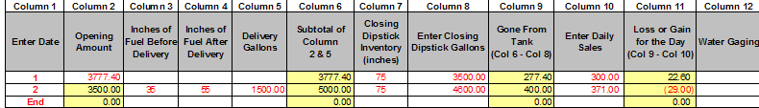

After you have entered the last day of information for the month, enter the word “END” on the next line. This will stop the automatic calculation for the rest of the spreadsheet.

Important: If you do not enter the word “END”, the calculations will not be correct.

Suspected releases must be reported to the State Fire Marshal (402) 471-9465 and the Department of Environmental Quality (402) 471-2186 within 24 hours of discovery.

NOTE: Automatic Tank Gauge Readings may be substituted for dipstick readings.

If you have any questions with this program, please contact the Deputy or the Main Office at 402-471-9465.

